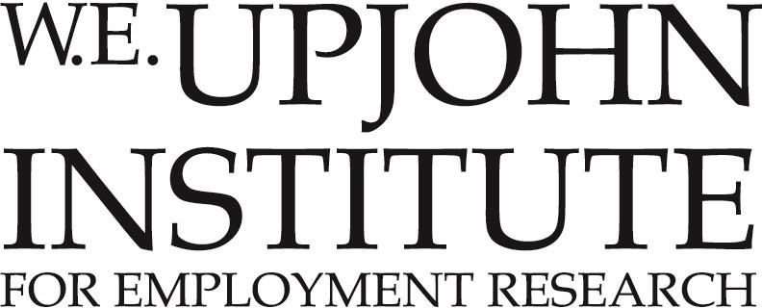

**JOB POSTING: CAREER COACH – Michigan Works! Southwest**

**(Branch/Calhoun)**

**POSITION SUMMARY**

Michigan Works! Southwest is seeking a talented Career Coach. The Career Coach provides career and case management services to job seeker customers within the designated service area of Michigan Works! Southwest. They assist job seekers in learning skills necessary to obtain permanent employment while also providing assistance with job search activities, employment and community service placement, training opportunities, and workshop facilitation. The Career Coach collaborates with other community agencies and partners to facilitate support services for job seekers as needed. They are also responsible for maintaining participant case files and completing required documentation in a timely and accurate manner.

This is a full-time non-exempt position requiring in-office/on-site work at the Michigan Works! Southwest locations in Branch and Calhoun counties. Occasional travel within the Michigan Works! Southwest four-county service area is required.

**POSITION REQUIREMENTS**

A bachelor’s degree or a minimum of three years of relevant work experience is required. To thrive in this role, experience in the employment field, non-profit sector, or with case management is preferred. Bilingual (English/Spanish) preferred. Proficiency in Microsoft Office products (Outlook, Word, Excel) is required.

Reliable transportation is required for occasional travel within the four-county service area of Kalamazoo, Calhoun, Branch, and St. Joseph counties.

**WAGES & BENEFITS**

This position offers a starting salary of $40,000 annually, as well as a generous benefit package. Offered benefits include health, dental, and vision insurance, short-term extended medical leave, long-term disability, parental leave, and a retirement plan.

**WHO WE ARE**

**Michigan Works! Southwest** strives to build connections between job seekers looking to grow their careers and employers seeking quality candidates with the necessary job skills.  This is accomplished by staying abreast of employment trends and maintaining critical relationships with community partners to ensure connections are made between employers, educators, trainers, and employees. Learn more at our website: <https://www.michiganworkssouthwest.org/>

**Michigan Works! Southwest** is within the **Center for Workforce Innovation and Solutions**, a division of the **Upjohn Institute**, and is committed to pioneering best practices in workforce development through program development, operation, and evaluation, striving to ensure successful outcomes for job seekers, employers, and communities.

Since 1932, the **Upjohn Institute** has functioned as one of the world’s leading independent, non-partisan, and non-profit labor economics research organizations, seeking to research the causes and effects of unemployment and to devise ways and means of alleviating hardships caused by unemployment.

All applicants and participants of the Michigan Works! Southwest Workforce Development Programs will be provided equal opportunity to participate in and benefit from all programs, activities, and services without regard to race, color, religion, national origin, age, sex, height, weight, marital status, disability, arrest record, or political affiliation or belief, or citizenship/status as a lawfully admitted immigrant authorized to work in the United States, or other non-merit factors.

The Upjohn Institute is an Equal Opportunity Employer and as such, is committed to affirmative action steps to help achieve a goal of equality in the treatment of employees and applicants without regard to race, color, religion, sex, sexual orientation, gender identity, marital status, age height, weight, national origin, veteran or disability status in hiring, promotion, training and development, compensation, transfer, termination, disciplinary action, and all other personnel actions and Institute related functions and activities.

**HOW TO APPLY**

Submit resume and letter of interest via Indeed by clicking [here](https://www.indeed.com/viewjob?jk=fa1e628f0b2e086d&from=shareddesktop_copy).